**UPLOAD FILE FROM ANGULAR 4 TO EXPRESS.JS**

REF:

<https://scotch.io/tutorials/angular-file-uploads-with-an-express-backend>

<https://www.npmjs.com/package/multer#readme>

<https://stackoverflow.com/questions/26287968/meanjs-413-request-entity-too-large>

FIRST IT’S NECCESSARY TO ADD CONFIGURATION IN OUR MIDDLEWARE EXPRESS SERVER, SPECIFYING ***urlencoded*** AND ***json*** BODY PARSER LIMIT:

***app.js*** FILE

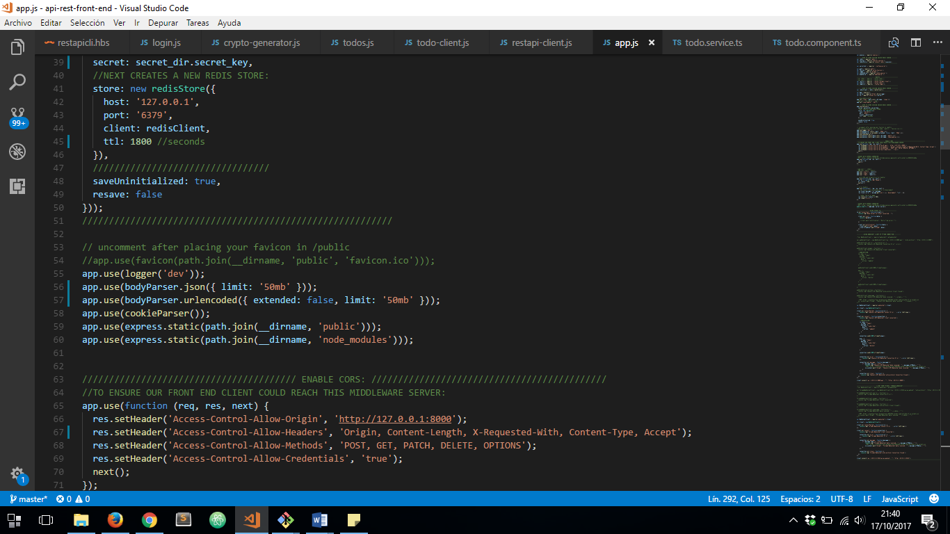

NEXT STEP IS TO INSTALL ***multer*** MODULE USING NPM:

***npm install multer –no-bin-links –save***

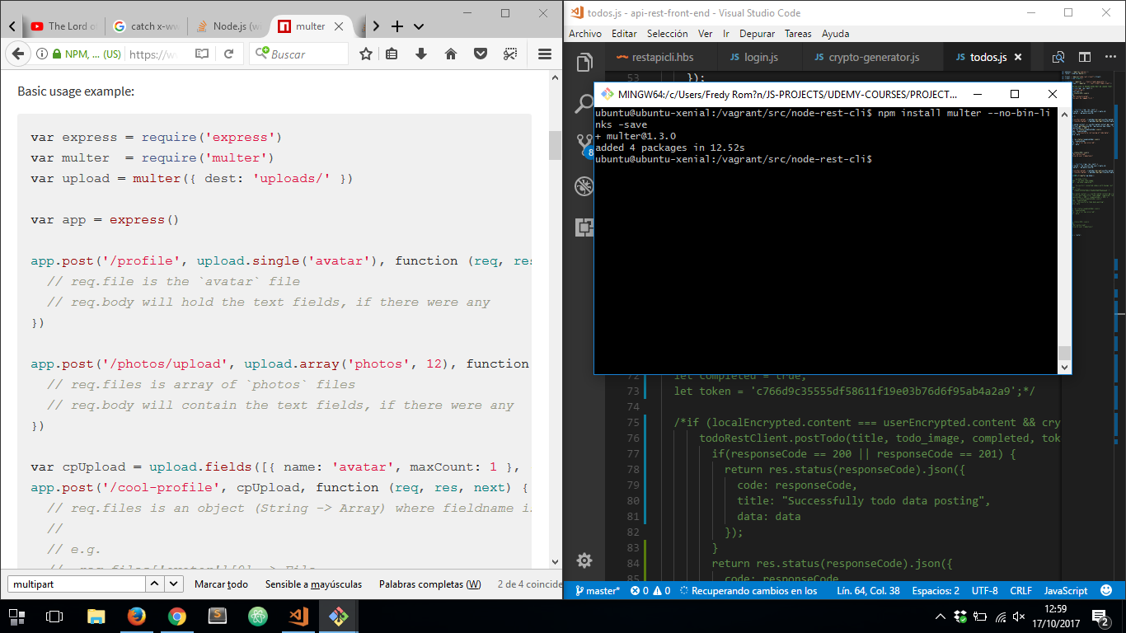

***package.js*** FILE

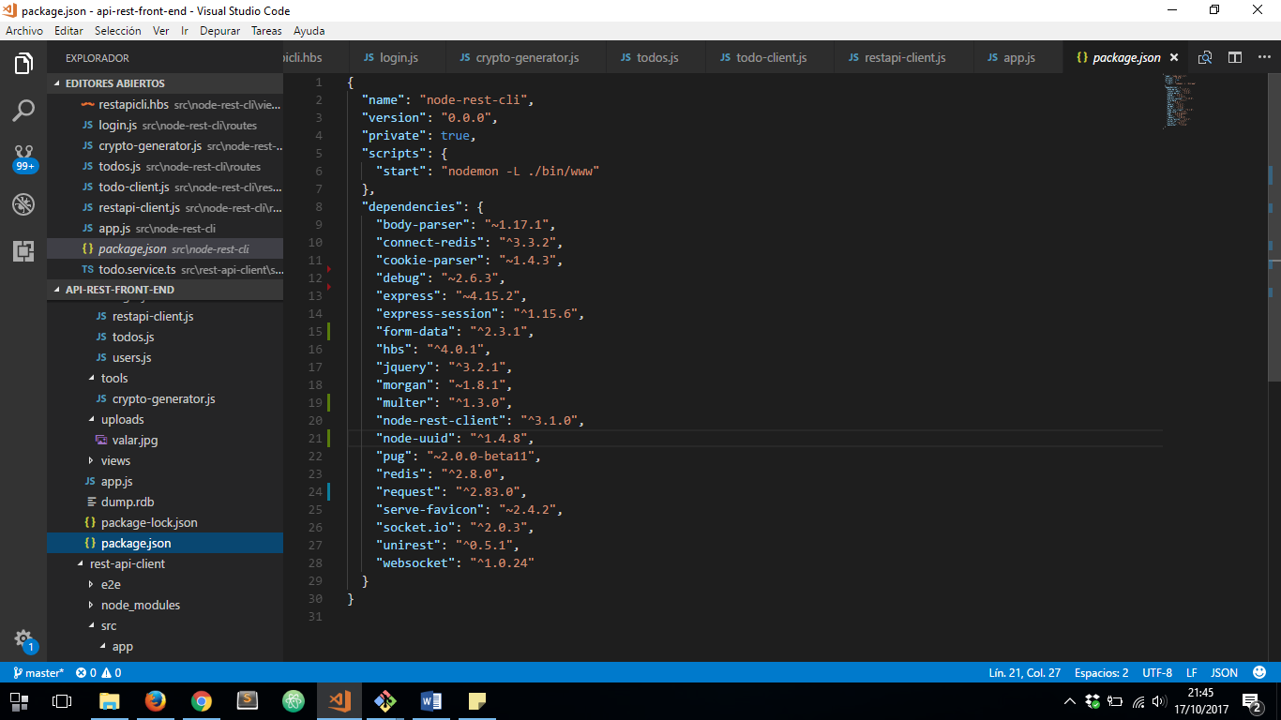

NOW LETS CONFIGURE OUR POST REQUEST ON EXPRESS APP:

***routes/todo.js***

1. IMPORTING MULTER MODULE
2. DEFINING UPLOADED FILES DESTINATION PATH
3. UPLOADING POST MULTIPART/FORM-DATA REQUEST FILE

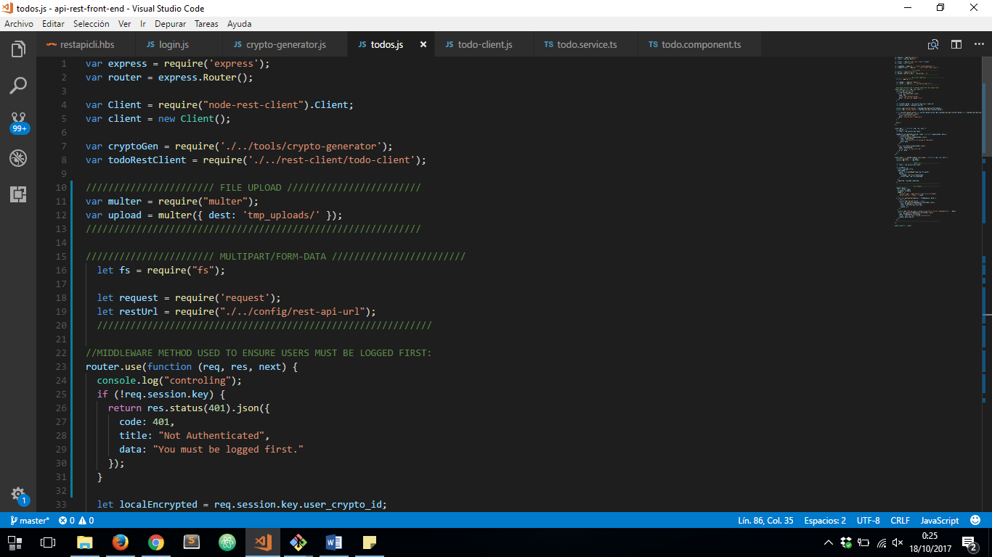

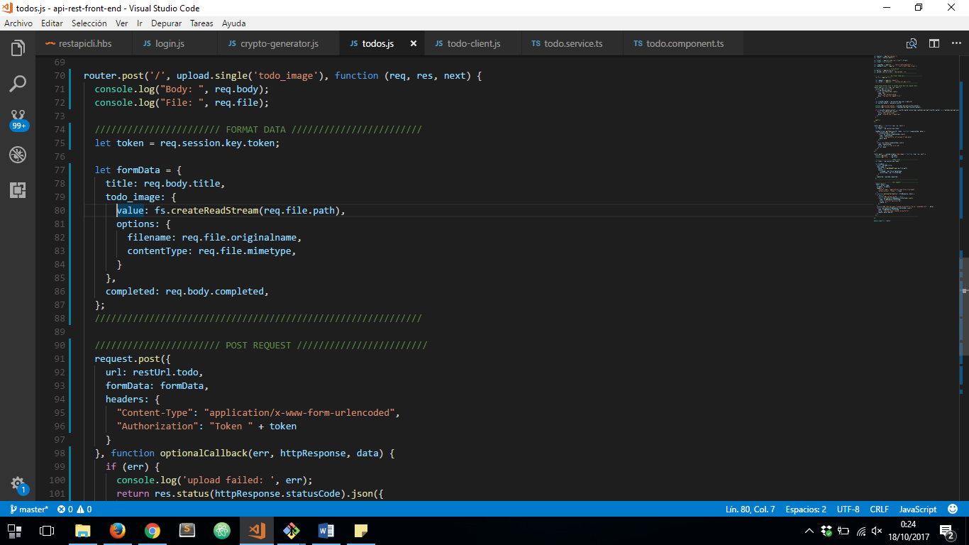

THEN WE HAVE TO PREPARE OUR FRONT-END ANGULAR 4 SERVER:

***todo.service.ts*** FILE:

1. ***addTodo*** METHOD MUST RECEIVE A ***FormData*** OBJECT
2. RETURNING NEW PROMISE
3. USING ***xhr XMLHttpRequest*** OBJECT TO PROCCESS THE POST REQUEST
4. CONFIGURING AND SENDING THE REQUEST

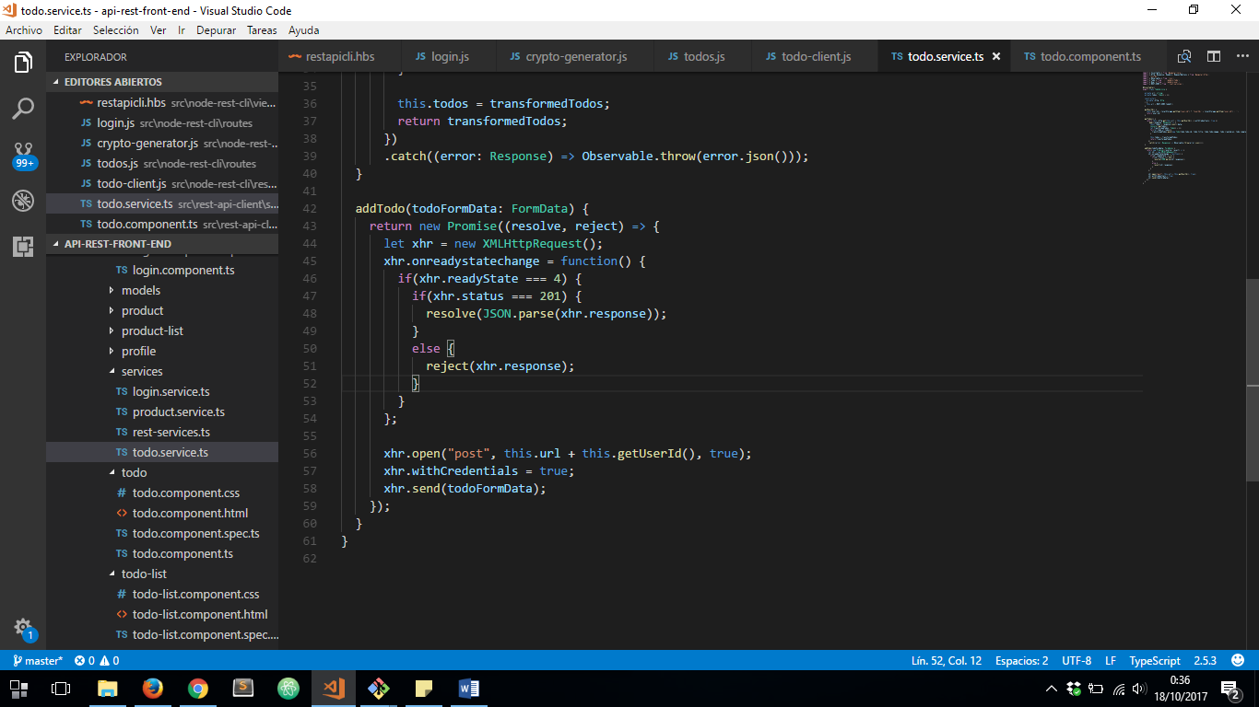

***todo.component.js*** FILE:

1. DECLARING ***fileToUpload*** ATTRIBUTE, AND DEFINNING ***fileChanged*** METHOD TO CATCH ***CHANGE EVENT*** FROM INPUT FILE OF THE DOM:

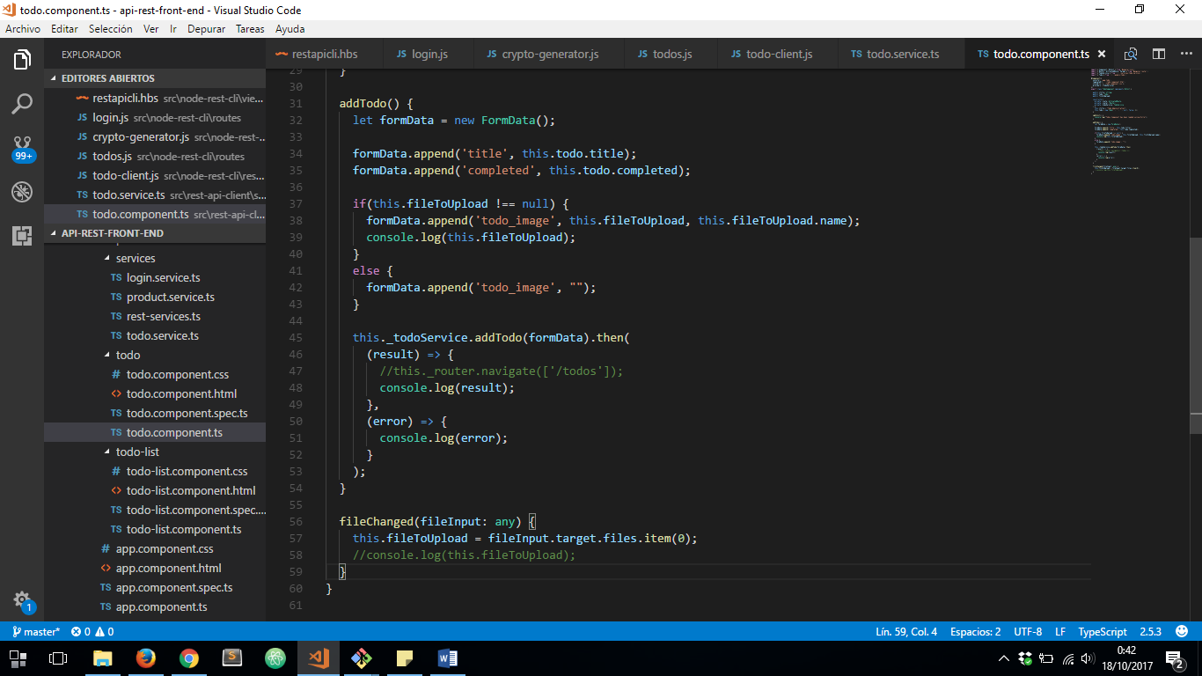

1. CALLING LAST EVENT ON ***todo.component.html*** FILE AND CATCHING ***ngSubmit*** EVENTWITH ***addTodo()*** METHOD:

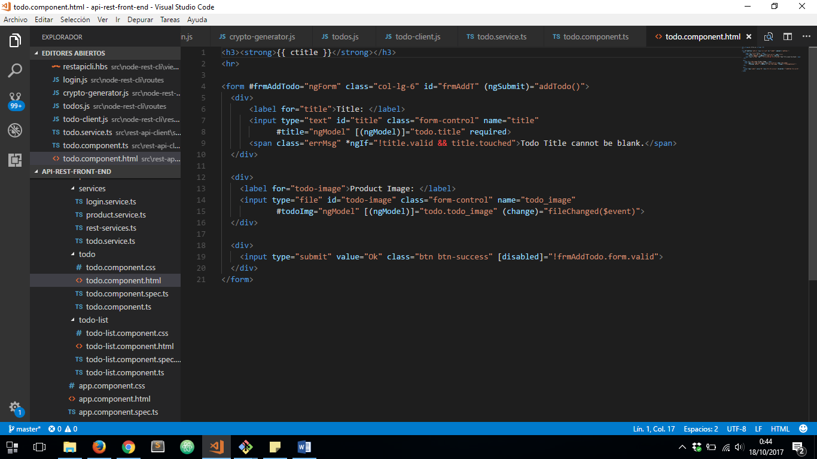

1. DEFINNING ***addTodo()*** METHOD TO CALL OUR PROMISE REQUEST METHOD FROM ***todo.service.ts***. WE HAVE TO PREPARE A FORM DATA OBJECT TO DO IT.

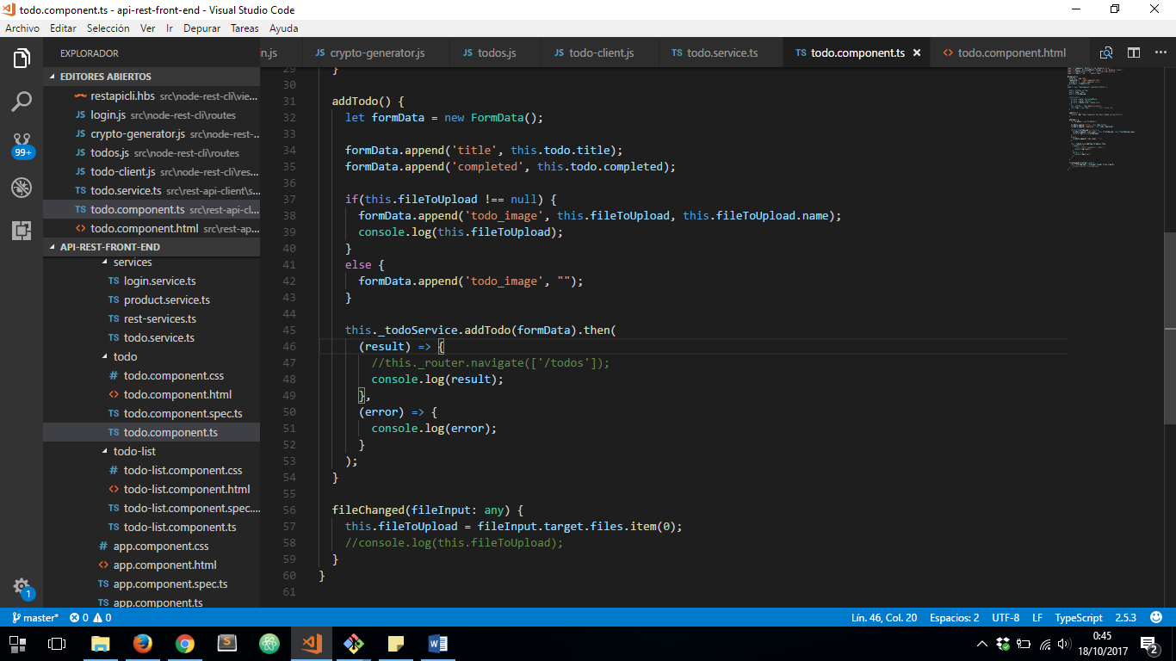

LET’S RUN OUR MIDDLEWARE SERVER WITH ***npm start –host=0.0.0.0***  AND OUR FRONT-END SERVER WITH ***ng serve –host=0.0.0.0***

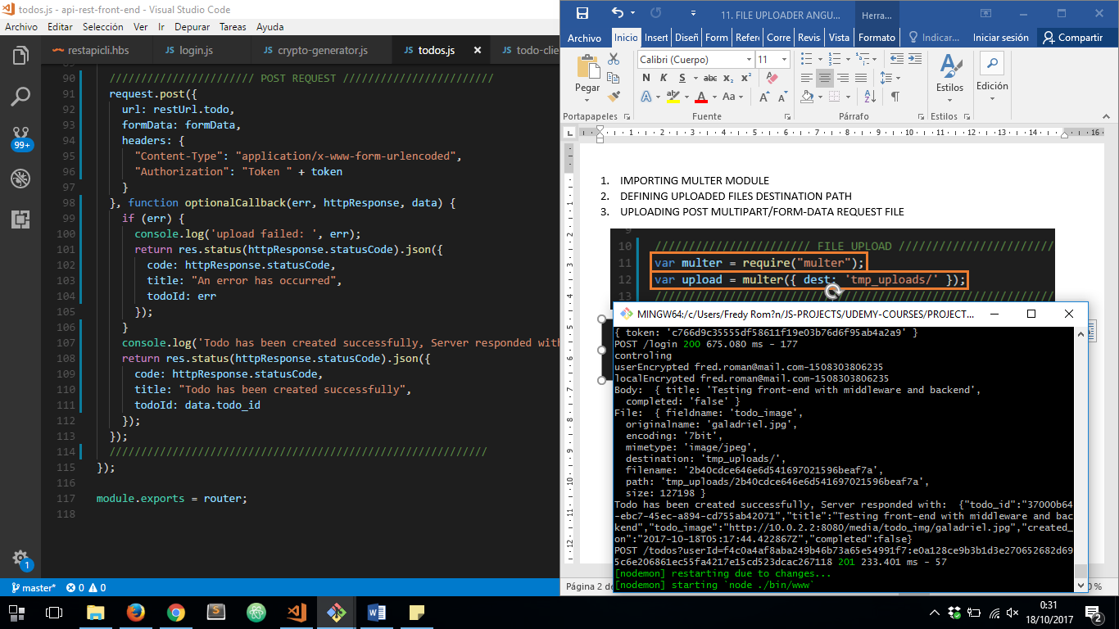

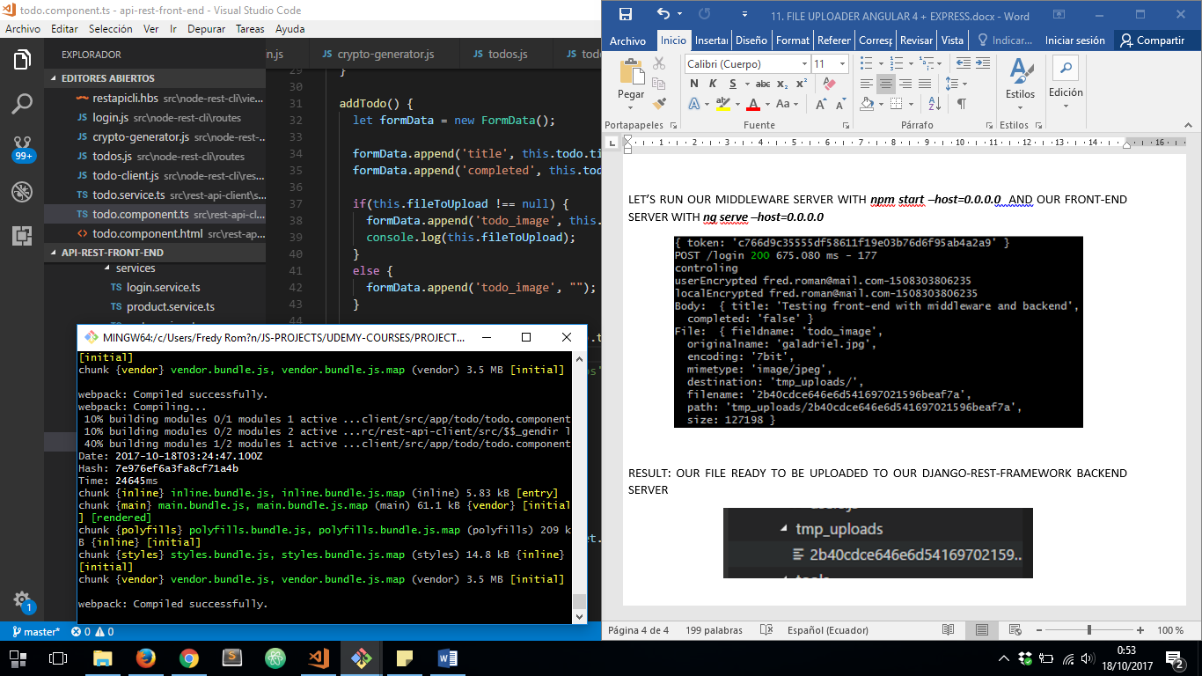

FROM ANGULAR 4 FRONT END CLIENT:

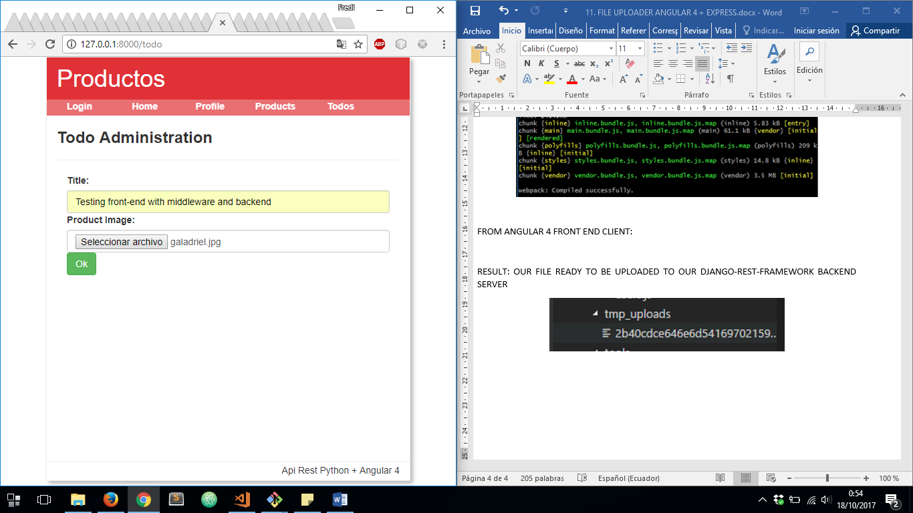

FRONT END CLIENT WEB BROWSER CONSOLE:

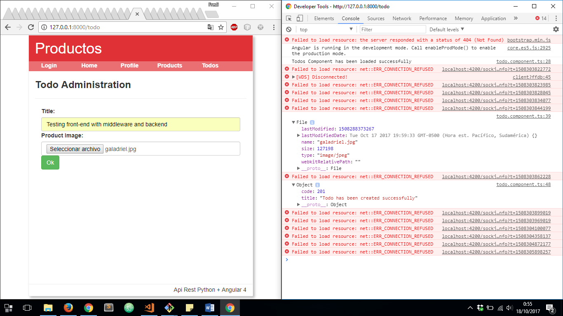

RESULT: OUR FILE READY TO BE UPLOADED FROM OUR EXPRESS.JS MIDDLEWARE SERVER TO OUR DJANGO-REST-FRAMEWORK BACKEND SERVER

